Overview:

Timely:

This program is primarily concerned with automated time tracking and visual job planning. It counts the amount of time you spend on tasks automatically and has a calendar-based interface where you can set aside time for them. For individuals and small teams who prefer automated time tracking with minimum manual input and a visual schedule depiction, this is perfect. (Timelyapp, 2024)

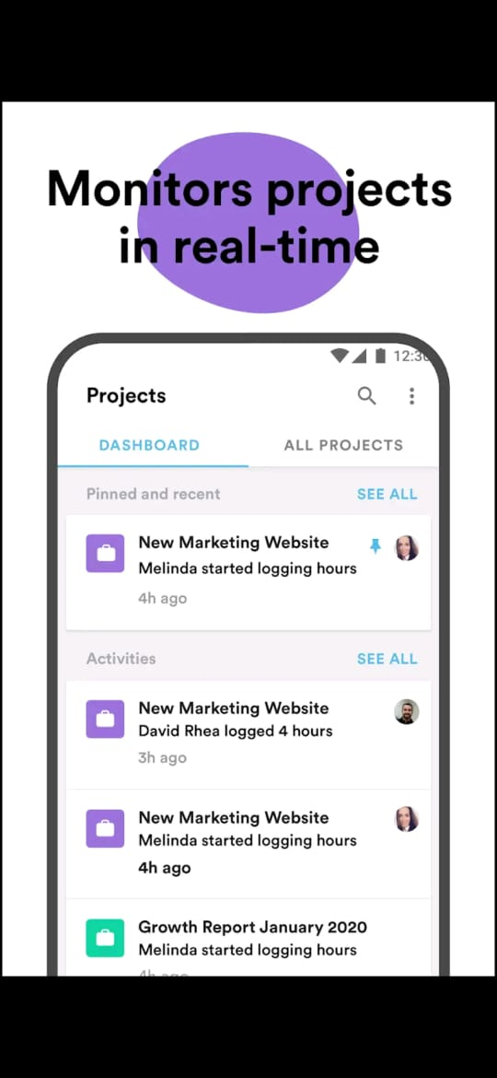

Users can monitor all project in real time as they are being worked on.

(Play, 2019)

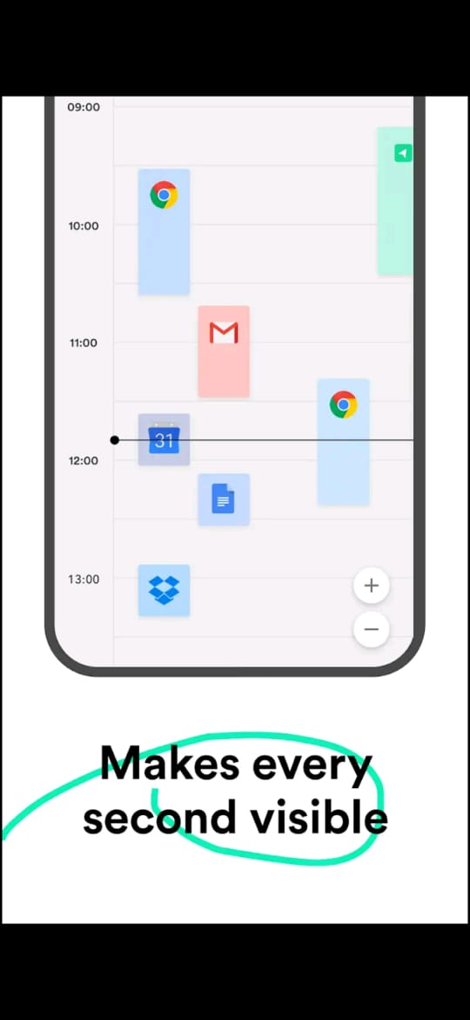

All the time spent on different tasks is shown to users to better understand where most to least time is spent. From here, users can see where time adjusting Is needed.

(Play, 2019)

TOGGL Track:

This app places a high value on usability and simplicity. Basic functionality including time tracking, project management, and reports are included under its free plan. It's an excellent option for independent contractors and small teams who want a simple and efficient approach to manage their time because of its user-friendly layout and functionality. (Toggl, 2024)

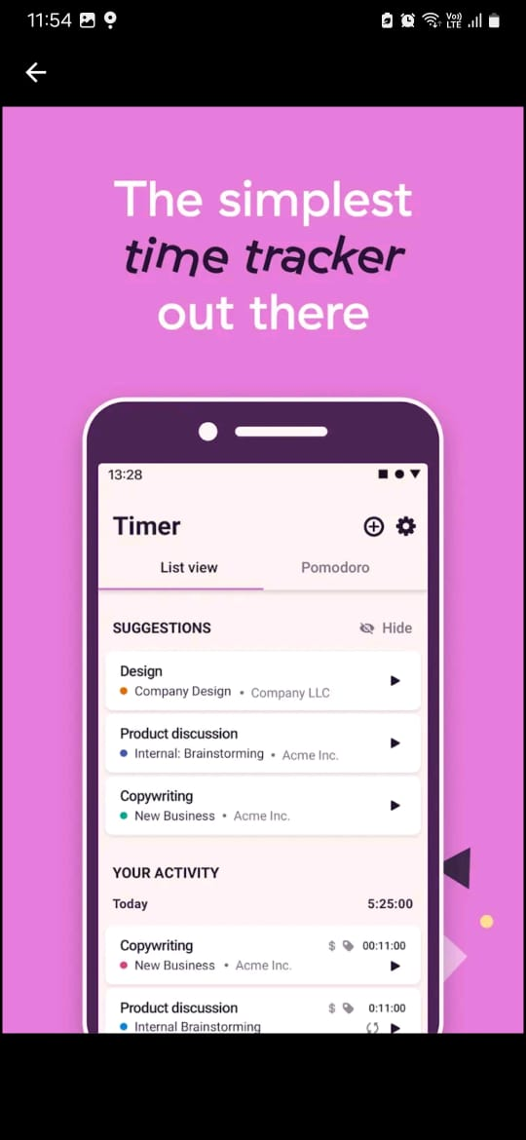

A list of all activity is displayed for the user along with time spent on those task/projects.

(Play, 2024)

Users can use reports to better allocate time in projects that are falling behind.

(Play, 2024)

Hour Stack:

Hour Stack: This application is well-known for its compatibility with Asana and Trello, two well-liked project management platforms. It is easy for teams that currently use those platforms because it lets you track time right within your project management workflow. It supports project-based work and streamlines timekeeping in the context of the current project management system. (Hourstack, 2024)

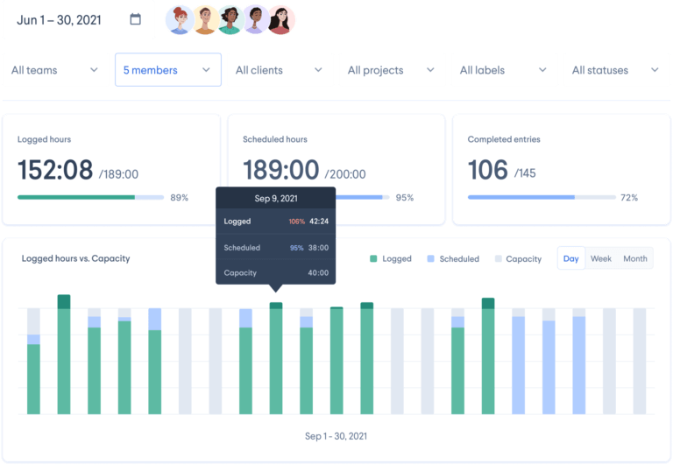

Users can log hours of all the time spent on tasks and projects.

(Google, 2024)

# References

Google, 2024. *Google.* [Online]   
Available at: https://www.google.com/url?sa=i&url=https%3A%2F%2Fwww.jibble.io%2Freviews%2Fhourstack&psig=AOvVaw2jjD7chCgjmn5ewUjGaph3&ust=1709546476483000&source=images&cd=vfe&opi=89978449&ved=0CBMQjRxqFwoTCPjamojr14QDFQAAAAAdAAAAABAH  
[Accessed 03 March 2024].

Hourstack, 2024. *Hourstack.* [Online]   
Available at: https://hourstack.com  
[Accessed 03 March 2024].

Play, G., 2019. *Google.* [Online]   
Available at: https://play.google.com/store/apps/details?id=com.timeapp.devlpmp&hl=en&gl=US  
[Accessed 03 March 2024].

Play, G., 2024. *Google Play.* [Online]   
Available at: https://play.google.com/store/search?q=toggl%20track&c=apps&hl=en&gl=US  
[Accessed 03 March 2024].

Timelyapp, 2024. *Timelyapp.* [Online]   
Available at: https://timelyapp.com/#:~:text=Automate%20your%20time%20tracking,desktop%20app%20automatically%20for%20you.  
[Accessed 03 March 2024].

Toggl, 2024. *Toggl.* [Online]   
Available at: https://toggl.com  
[Accessed 03 March 2024].